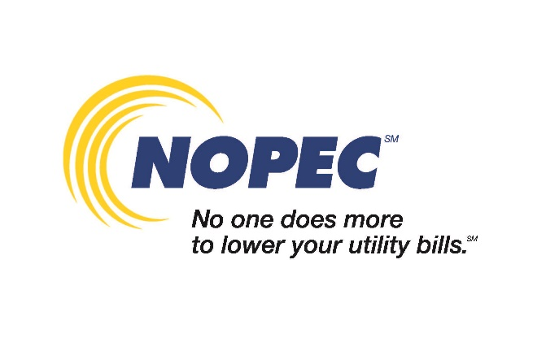
COPY FOR USE ON WEBSITES OR WATER BILL INSERTS
Please include NOPEC logo
(Community Name) is a member of NOPEC’s (natural gas, electric, natural gas and electric) aggregation program(s). As a nonprofit group of 240 Ohio communities, NOPEC negotiates lower utility rates. In fact, over the past 20 years, NOPEC has saved Ohio consumers hundreds of millions of dollars on their energy costs. NOPEC also provides member communities with energy-saving grants, low-interest rate financing for energy-efficiency projects, and community outreach programs to help residents learn how to save even more. For more information about NOPEC, go to nopec.org.

