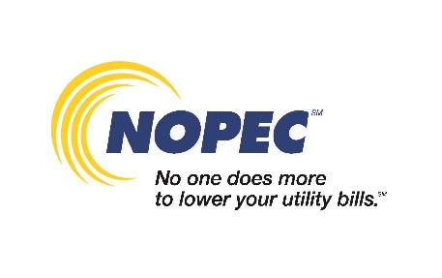

RESIDENTS TO RECEIVE NATURAL GAS AGGREGATION ENROLLMENT MAILERS
Eligible residents and small business owners will be receiving a natural gas enrollment letter for (add name of community)’s natural gas aggregation program through NOPEC. NOPEC is required by the Public Utilities Commission of Ohio (PUCO) to send these letters to all eligible residential and small business customers in NOPEC member communities every two years. Letters will begin mailing in early November for enrollment into the natural gas program for the period beginning January 2022 through June 2023.
If you want to enroll in NOPEC’s Standard Program Price, you don’t need to take any action when you receive your enrollment letter. You will automatically be enrolled. Additional program options including fixed term and monthly variable pricing can be viewed online at nopec.org/checkrates or by calling NOPEC’s Customer Care Center at 1-855-667-3201. If you don’t want to enroll in the natural gas aggregation, you must return the opt-out form included with your enrollment letter to NOPEC by mail or by fax to 440-774-4422 by no later than December 13, 2021.

